Name: Ugochukwu Achara, Samuel Ibikunle and Olivia Ngueguim
Class; MSBA 653
Prof. Brittany Green
Assignment 1

Case Context and Problem Framing
What is the core business problem to solve? Explain the relevance of this problem to the subscription company.
The value of any business comes from its ability to adequately and consistently meet needs of their customers. This is often reflected in customer satisfaction, retention and expansion. In this case, we are looking at company’s historical data to find trends in customer behavior that may result in them churning. This discovery will be used to create a model that will be able to predict customer churn based on customer characteristics, behavior, company offerings, etc. With the model, we can take preventative action to stop customers churning by better meeting their needs, improving company services and offerings for better customer retention and ultimately the bottom line.
Identify whether this is a supervised or unsupervised learning problem. If supervised, specify whether it is a classification or regression problem and justify your reasoning.
This is a supervised learning problem as it is data with a response with the goal of predicting said response variable. It is a classification problem as we want to determine customer churn or not.
Data Exploration (EDA)
What is the response variable? Provide one appropriate visualization or table to show the distribution of the response variable.
The response variable is “left Flag” which is categorical and shows whether customer left the company or not.
Frequency table (left Flag(churn))
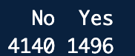
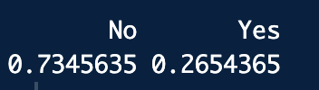
State the number of observations and predictor variables in the dataset.
There are 5,636 observations and 33 predictor variables. The account references and customer ID are identifiers, so they are not predictor variables that have any effect on the response variable (left flag) which is why they are 33 predictor variables.
Classify variables as categorical, continuous, date variables, or other types.
Identifier Features | Categorical Features | Numeric Features
Acct ref  Cust ref |  | Tenure mo  Monthly fee  Total billed  Age years  Dependent count  Referrals count  Avg long dist fee  Avg gb download  Refunds total  Extra data fees total  Long dist fees total
  Has dependents  Home phone  Multi line  Internet line  Add on security  Add on backup  Add on protection  Tech support std  Stream TV  Stream music  Unlimited data opt | Stream movies  Contract term  E bill opt in  Pay method  Left flag  Fiscal qtr  Gender  Is married  Referred friend  Recent offer  Internet tech  Premium support

Data Quality Assessment
Examine the dataset for missing values, NULL values, outliers, or inconsistencies. Summarize any issues found and discuss their implications for analysis.
Total billed has 8 missing values which could be because the bill has not been calculated yet for the customer or has not been uploaded into the dataset. For further analysis, the avg total billed can be used to replace these values to maintain the integrity of the dataset.
Recent offer has 3106 which could be because an offer has not been sent out to these customers yet. This is also a categorical variable with just over 50% of total observations not accounted for. Nonetheless, this will not of significance at this point because the model which will be created will be used to determine customers more likely to churn and thus will be sent an offer to present churning. It also make sense that not every single customer is being sent an offer. After further analysis and depending on where the customer falls (churn likely or not), we can determine whether they should receive an offer and which package.
Internet tech has 1212 which points to the speed of the customer connection depending on whether users are on DSL(Digital Subscriber Line 5 – 100 mbps), Cable (5 – 1000 mbps) or Fiber optic 100 – 5+ gbps). This is an important variable since it may explain customer satisfaction with their current service. However, we have enough information in our dataset to determine whether this is a statistically viable variable that contributes to customer churn by comparing the different customer speeds. Additionally, the missing values can be used as variable in understanding whether internet speed is a non-factor in customer churn.
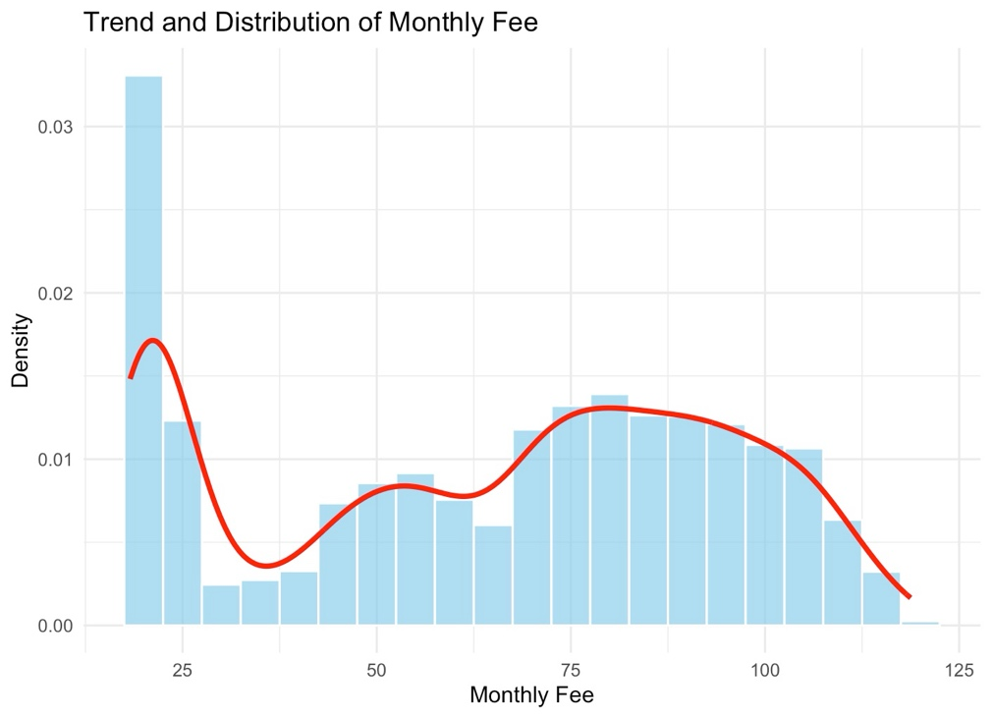
Individual part: Ugochukwu Achara

The above trend shows the distribution of monthly fee across the customer base for Q3. The chart shows that majority of customers pay less than $25 for their plan which may point to cheaper plans being more popular than pricier plans. Additionally, the average monthly fee of customers that churn is higher at $74.1 dollars compared to customers that do not $61.4 showing where the company can focus their attention while finding ways to make their expensive plans more appealing.
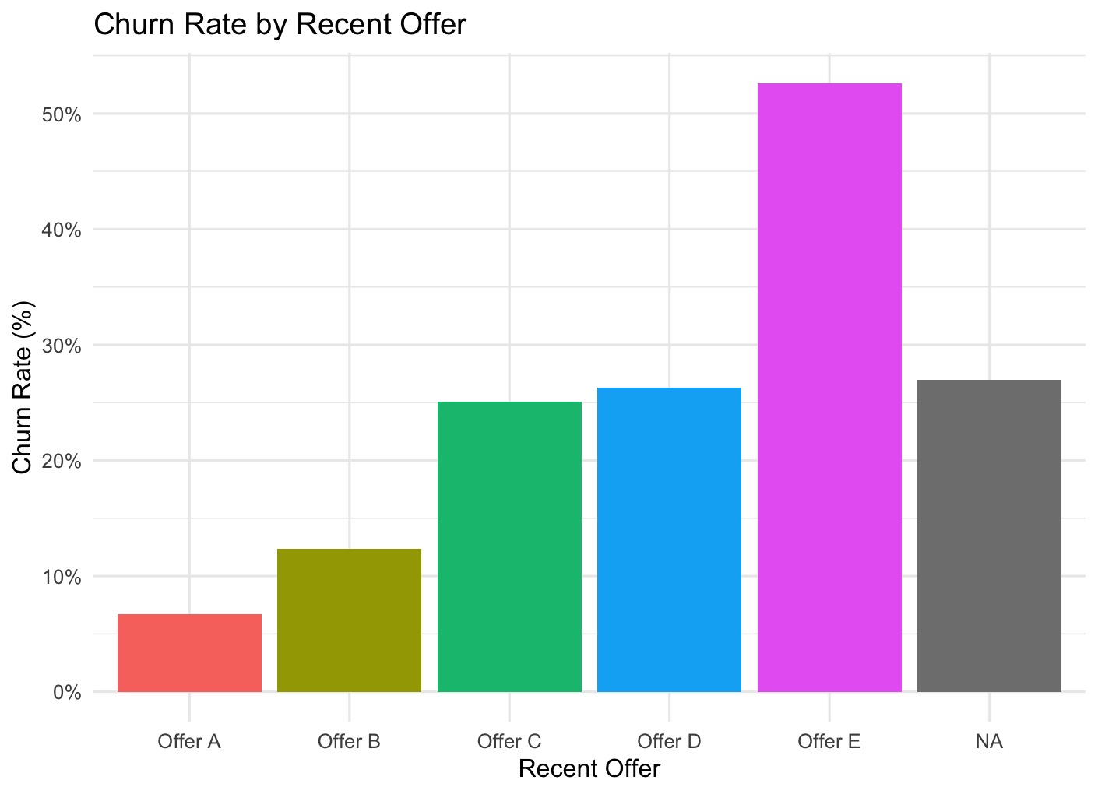
The above chart shows recent offers to the customers in hopes of retaining them at the end of their current contracts. Customers who received offer E ended up leaving at a significantly higher rate than any other offer and those who did not receive at offer at all. Possible causes point to the structure of the offer itself, the customer base which this offer is usually presented to, and its perceived value to the customer base. Additionally, it is important to note that while some offers will lead to short-term retention but long-term churn. The business should start by reevaluating Offer E closely as well as the customer base that are most likely to receive said offer. This information can be used to restructure the offer in comparisons to other offers that do a better job of getting customers to renew their contracts.
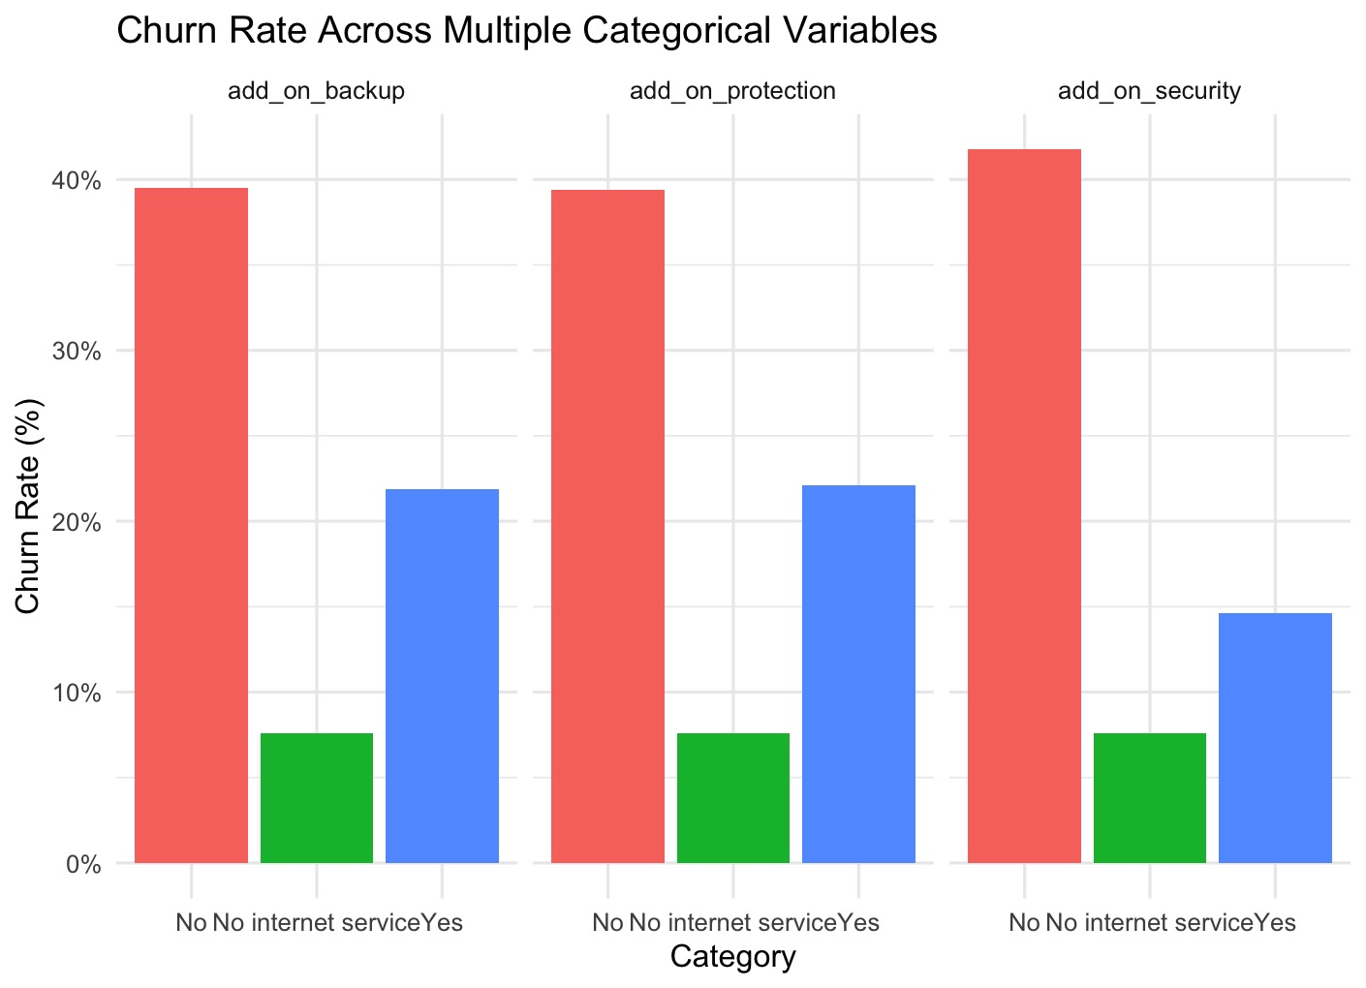
The chart shows various add on options and how most customers that declined these options are more likely to churn compared to customers that have these add on options. Knowing this, the business should introduce a bundle package that encourages customers to add on to their plans. This will increase the perceived value of the plan as well as discourage churning since they will not be losing a single service but multiple. These bundle package can be discounted as well or even provided for free for a period so that customers can get acquitted with them to gauge the value for themselves.

Individual part: Olivia Ngueguim
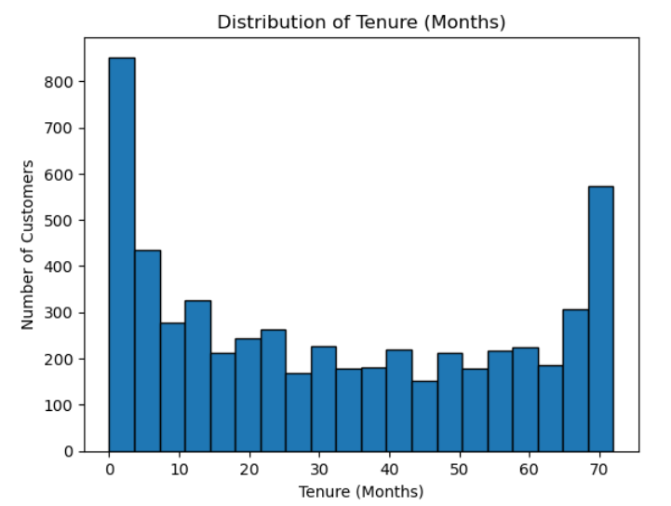
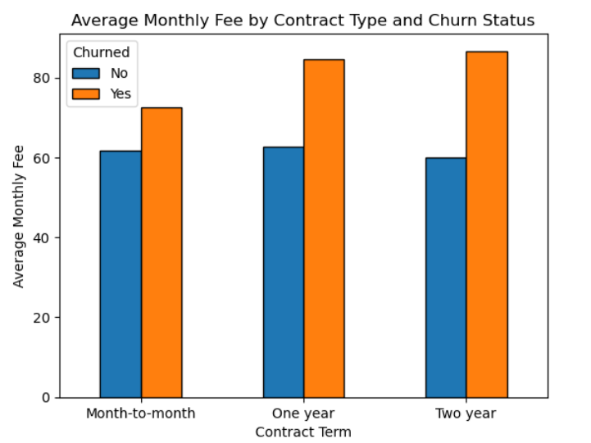
We observe a very high numbers of new customers, which indicates that most of our customer that leaves happens very early during initial experience with the structure. This initial period is important because if we can keep customers beyond the first 1-2 months, they are more likely to stay, with many remaining for years, as shown by the high bar at the very end which represents these loyal, long term customers. Therefore, we should focus on improving our onboarding process and initial customer experience by implementing program with personalized check-ins for new customers, especially within the first 60 days, to address these issues early and prevent them from leaving.

Based on our graph, we can see that the monthly average charges vary significantly across different contract types. The data shows us that month-to-month customers consistently pay the highest average fees. We can use this finding to understand that these customers, because of their high monthly cost and lack of long term commitment, are a significant churn risk. This makes these customers targeted for our retention efforts, as their higher fees might make them more likely to leave for a cheaper alternative. We use this insight to prioritize strategies that offer incentives to move them onto a more stable, lower cost contract.
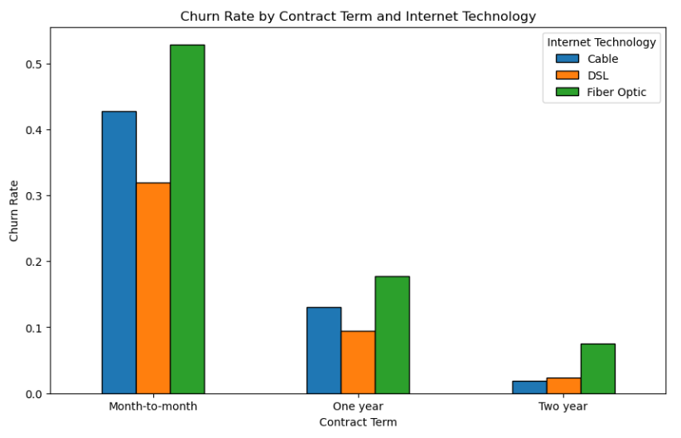
The graph shows that fiber internet customers leave their service more often than people with Cable or DSL. The customers most likely to quit are those who have Fiber internet and pay each month. This is true even for customers with longer term agreements; they still leave more often than others. Reasons could be the price, other companies offering better deals, or problems with installation. we should pay close attention to this high-risk Fiber group. we can try to keep these customers by offering special deals like steady prices, gifts, or fixing service issues to make them stay.

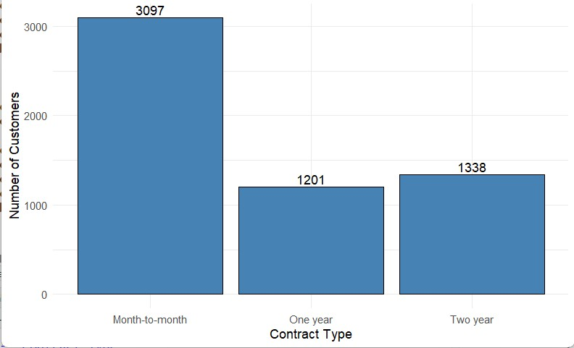
Individual part: Samuel Ibikunle
Purpose: Why this chart is appropriate and what the pattern shows.
The purpose of the chart is to show the different contract types for the customers. We are able to see the distribution of customers across different charts, and the chart highlights that there are a lot of customers who are on month-to-month contracts.
So what? (Why it matters for customer churn/retention?)
The month-to-month contracts are less risky for customers because they are able to cancel anytime they like. This is a disadvantage for the company because this could potentially lead to a lot of churning because while flexibility can attract a lot of customers initially, it also makes retention very difficult.
Business takeaway: Now what should the business do to improve given your
findings?
The business should push to get more people to sign up for the longer contract by offering discounts and bundles that can incentivize the customer to sign a longer contract.
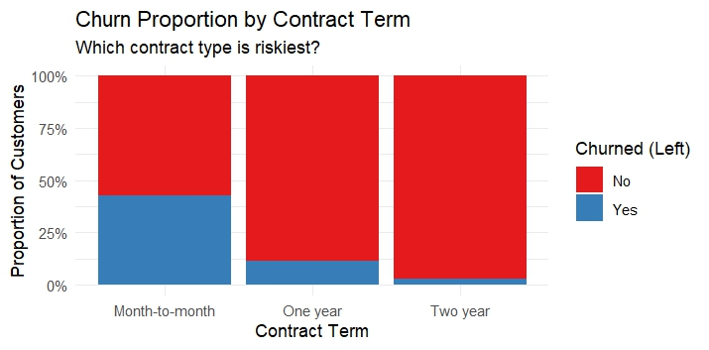
Purpose: Why this chart is appropriate and what the pattern shows.
The purpose of this chart is to show the contract term of the customer and how many customers are churning based on their contract type. The chart makes it easy to see whether churning is specific to a contract group.
So what? (Why it matters for customer churn/retention?)
It shows that a lot of customers on the month-to-month contract are more likely to churn. Because these customers face no cancellation fees, they are more likely to explore other options, and this can lead to unstable revenue for the company
Business takeaway: Now what should the business do to improve given your
findings?
The business needs to spend more money on training employees to convince customers to sign a longer contract. They could also offer discounts and loyalty perks to keep customers around
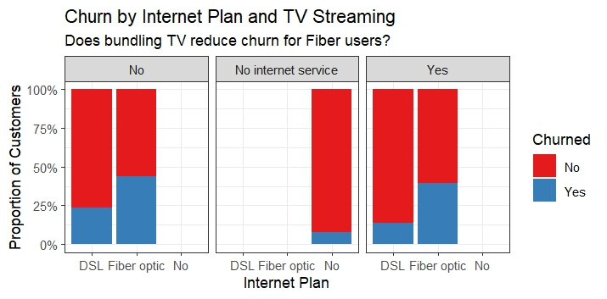
Purpose: Why this chart is appropriate and what the pattern shows.
The purpose of this chart is to see if the company is able to keep a customer if they are able to bundle a TV plan with their internet service. The chart can help to determine whether it would be advantageous to offer a bundle plan
So what? (Why it matters for customer churn/retention?)
Even though the difference is not big, the data indicates that the company is able to keep more customers who have a bundled plan than those who do not.
Business takeaway: Now what should the business do to improve given your
findings?
The company should focus on convincing customers to get a bundled plan. By strengthening the bundle plan. The company can make sure they are able reduce churning while also attracting more customers

Team Insights and Recommendations
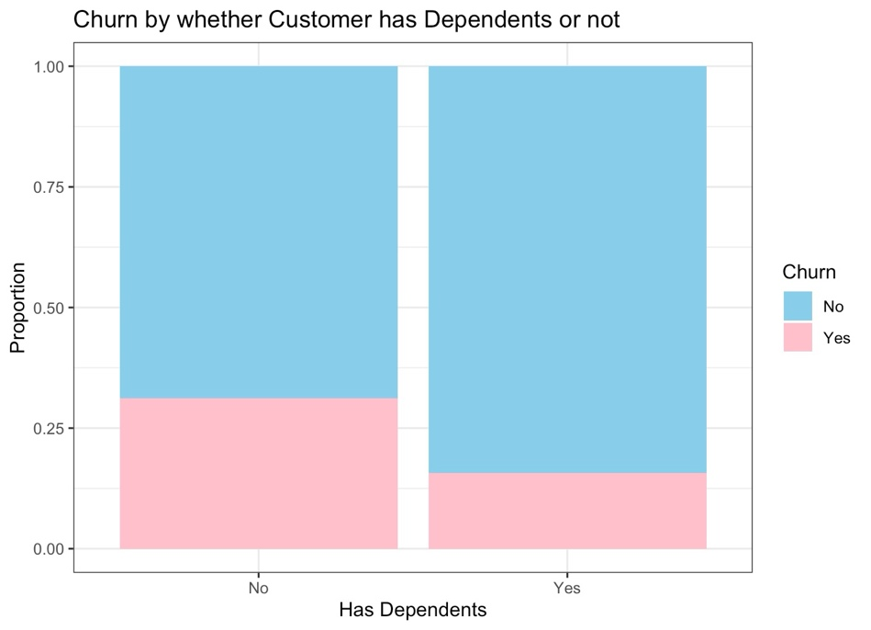This chart shows that Customers with dependents are less likely to churn as opposed to customers without. This matters because the company can take into account the offerings it has for customers with dependents and specific targeted promotions to retain said customers as well as increase this customer base. Targeting this customer base will help reduce the overall customer churn rate.

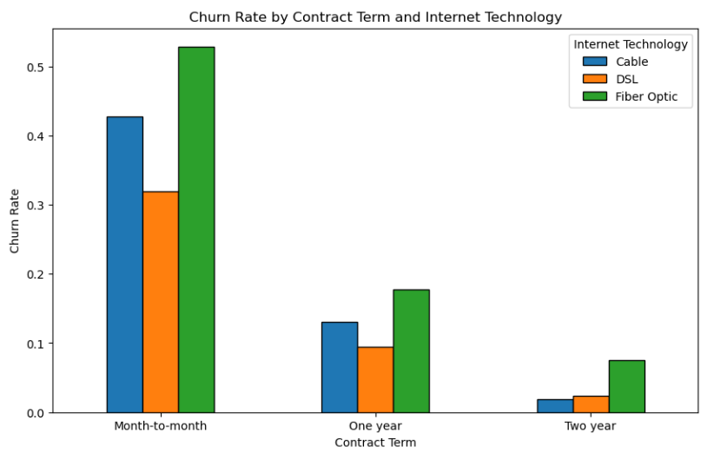This chart shows that customer churn rate is highest among customers that have a month-to-month contract and has a fiber optic (faster) connection. With fiber optic being the fastest internet connection, the price associated both monthly and on longer contracts are much higher and as such lead to customer churn. In order words, the customers don’t see the value as opposed to other internet technology offerings. This is the same across the board on all contract terms. Our recommendation is to focus their resources on promoting the other internet technology while working to improve the fiber optic connection. The business should incentivize monthly customers to signing longer contracts while also improving the pecks of their monthly contracts.

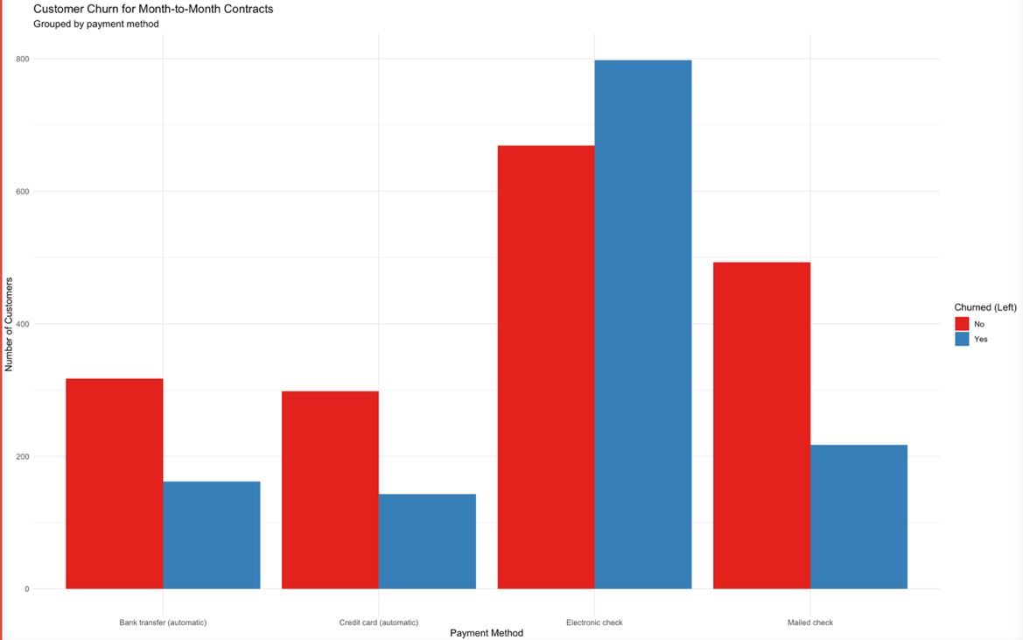
Having noticed that the most likely customers to churn are the ones on monthly contracts, we discovered that customers that pay through electronic check are the most likely to churn. Payment method isn’t a significant factor for yearly or two-year contracts. Our recommendation is that the business find ways to make payment methods more accessible to monthly customers or increase their payment method by incorporating services such as apple pay, google pay and other online payment methods. This will not only help with monthly customers but the entire customer base.

